embedUR Systems
Campus Training Program – 2026
LINUX TRAINING – ASSESSMENT 5
Name : Muhesh M
College :Thiagarajar College of Engineering, Madurai.
Create a Bash script 'file_analyzer.sh', to demonstrate the following concepts:
1. Recursive functions
- Write a recursive function to search for files in a directory and its subdirectories containing a specific keyword.
2. Redirection and error handling
- Log errors (e.g., invalid arguments, missing files) to 'errors.log' and display them in the terminal.
3. Here document and here string
- Use a here document to display a help menu when the '--help' option is passed.
- Search for a keyword in a specified file using a here string
4. Special parameters
- Use parameters like '$0', '$#', '$?' and '$@' to provide meaningful feedback.
5. Regular expressions
- Validate inputs with regular expressions (Check if the file exists and the keyword is not empty and valid)
6. Command-line arguments using getopts
Use 'getopts' to handle:
'-d <directory>': Directory to search.
'-k <keyword>': Keyword to search.
'-f <file>': File to search directly.
'--help': Display the help menu.
Example usage:
# Recursively search a directory for a keyword
./file_analyzer.sh -d logs -k error
# Search for a keyword in a file
./file_analyzer.sh -f script.sh -k TODO
# Display the help menu
./file_analyzer.sh--help

BASH SCRIPT file_analyzer.sh

#!/bin/bash

log_error() {
echo "[ERROR] $1" >&2
echo "[ERROR] $1" >> errors.log
}

if [[ "$1" == "--help" ]]; then
cat << EOF
Usage: $0 [OPTIONS]

Options:
-d <directory> Directory to search recursively
-f <file> File to search directly
-k <keyword> Keyword to search
--help Display this help menu

Examples:
$0 -d logs -k error
$0 -f script.sh -k TODO
EOF
exit 0
fi

while getopts ":d:f:k:" opt; do
case "$opt" in
d) search_dir="$OPTARG" ;;
f) search_file="$OPTARG" ;;
k) keyword="$OPTARG" ;;
\?) log_error "Invalid option: -$OPTARG"; exit 1 ;;
:) log_error "Option -$OPTARG requires an argument"; exit 1 ;;
esac
done

if [[ -z "$keyword" || ! "$keyword" =~ ^[a-zA-Z0-9_]+$ ]]; then
log_error "Empty or invalid keyword"
exit 1
fi

if [[ -n "$search_file" && ! -f "$search_file" ]]; then
log_error "File does not exist: $search_file"
exit 1
fi

if [[ -n "$search_dir" && ! -d "$search_dir" ]]; then
log_error "Directory does not exist: $search_dir"
exit 1
fi

if [[ -z "$search_file" && -z "$search_dir" ]]; then
log_error "Either -f or -d must be specified"
exit 1
fi

recursive_search() {
local dir="$1"
local key="$2"

for item in "$dir"/*; do
if [[ -f "$item" ]]; then
grep -q "$key" "$item"
if [[ $? -eq 0 ]]; then
echo "Found in file: $item"
fi
elif [[ -d "$item" ]]; then
recursive_search "$item" "$key"
fi
done
}

if [[ -n "$search_file" ]]; then
if grep -q "$keyword" <<< "$(cat "$search_file")"; then
echo "Keyword '$keyword' found in $search_file"
else
log_error "Keyword '$keyword' not found in $search_file"
fi
fi

if [[ -n "$search_dir" ]]; then
recursive_search "$search_dir" "$keyword"
fi

echo "Script name: $0"
echo "Arguments passed: $@"

TEST CASES

Test case - 1 : Searching for a keyword in a file
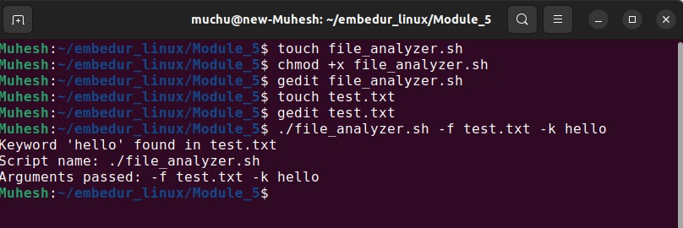

Test case - 2 : Checking for a keyword which is not in a file
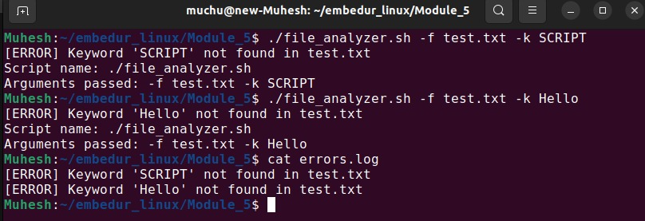

Test case - 3 : Accessing a file with invalid option , no arguments
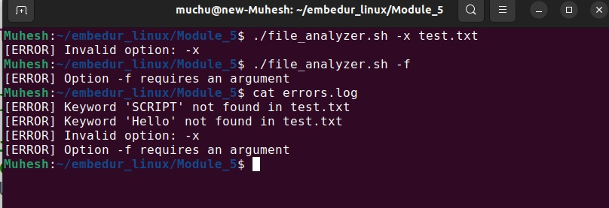

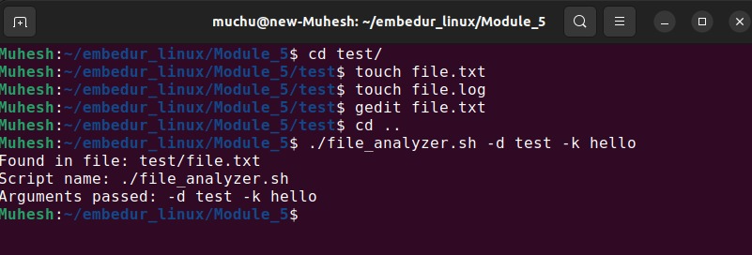
Test case - 4 : Searching for a keyword in a directory

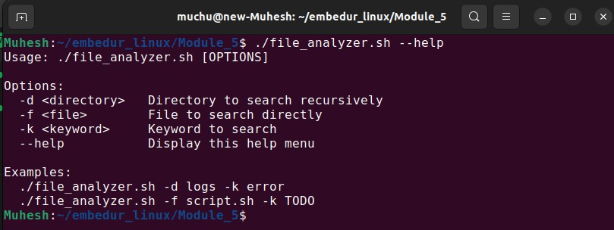
Test case - 5 : Display the help menu

